**Home Page (Page-1)**

🡪 Inputs (all 3)

Inputs:

1. Image upload (Should take the text)
2. Paste a direct text.
3. Paste a News Web site link (Web-scrapping)

**Tasks Page (Page-2)**

🡪 News Translation

🡪 News Categorization

🡪 News Summarization

🡪 Data-set Analysis Report

**Tasks**  
🡪Translator (source and destination)  
🡪News Categorization  
🡪News Summarizer

🡪Basic EDA

**Output**

🡪 Translated Text  
🡪 Categorized News  
🡪

**Data Pre-Processing**

🡪 Data preparation and Feature Extraction

🡪 Feature Selection

Text 🡪

**News categorization**

1. Sports
2. Business
3. Politics
4. Tech
5. Entertainment

**Using Multinomial Naive Bayes**  
Multinomial Naive Bayes is one of the variations of the Naive Bayes algorithm in machine learning which is very useful to use on a dataset that is distributed multinomially. When there are multiple classes to classify, this algorithm can be used because to predict the label of the text it calculates the probability of each label for the input text and then generates the label with the highest probability as output.

**Using LSTM**

**1. Forgetting Mechanism:** Forget all scene related information that is not worth remembering.

**2. Saving Mechanism:** Save information that is important and can help in the future.

NLTK Library 🡪 (NLTK) is a Python library for working with natural language processing (NLP) tasks, such as segmenting words or phrases to performing advanced tasks, such as parsing and text classification.

Coding:

LSTM

<https://www.kaggle.com/code/mohamedbakrey/make-a-classification-for-bbc-news-by-lstm#Using-Model-LSTM>

Multi-Nomial

<https://thecleverprogrammer.com/2021/10/07/news-classification-with-machine-learning/>

References:

<https://www.analyticsvidhya.com/blog/2021/01/understanding-architecture-of-lstm/>

The Times of India

Indian Express





India Today

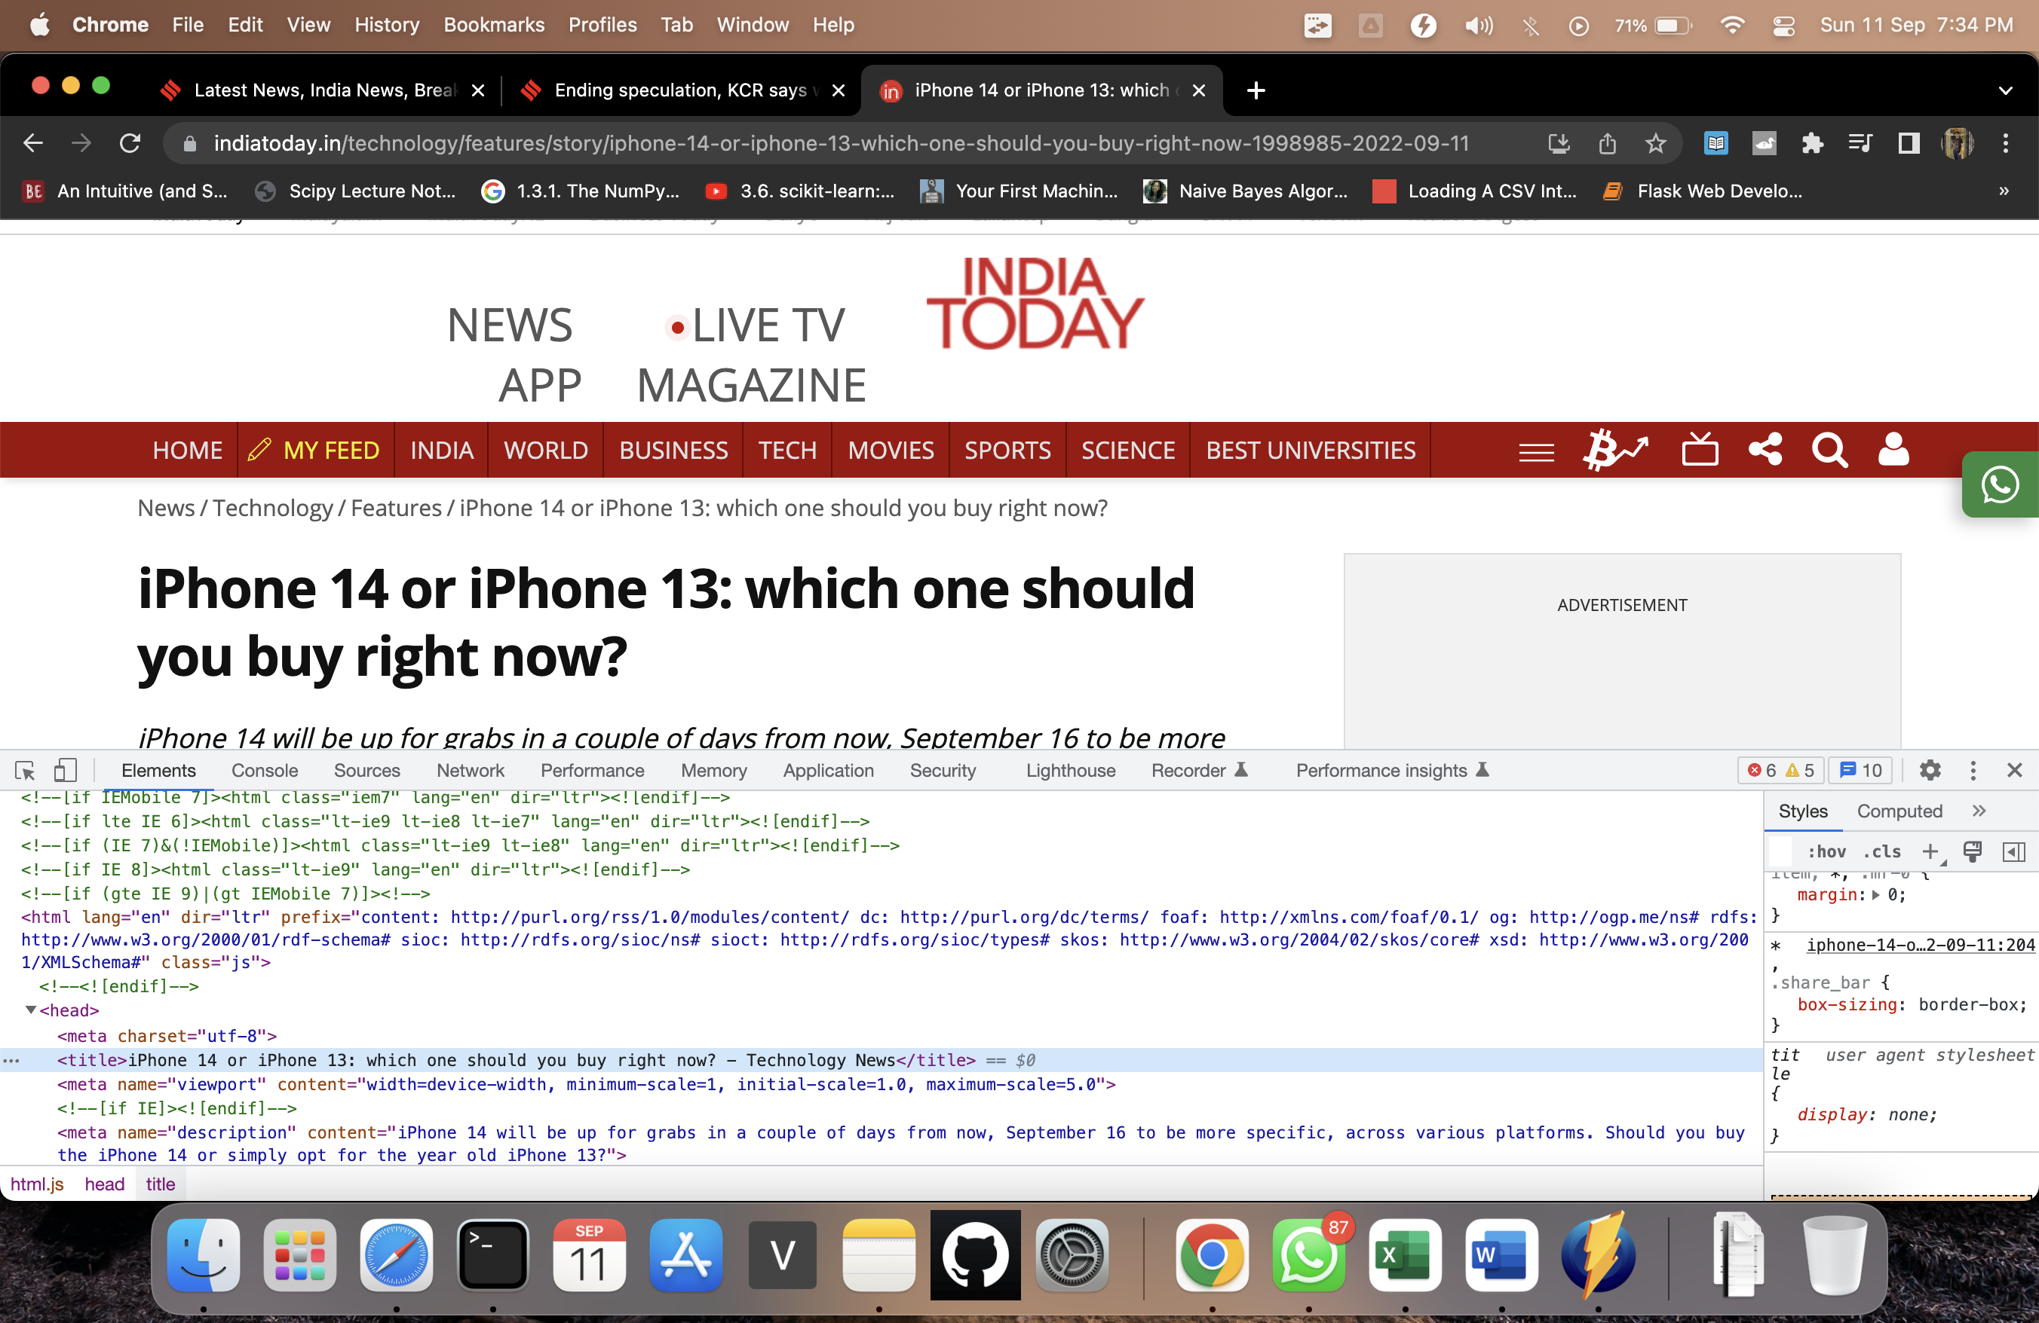

<head> <title>

NDTV

Hindustan times

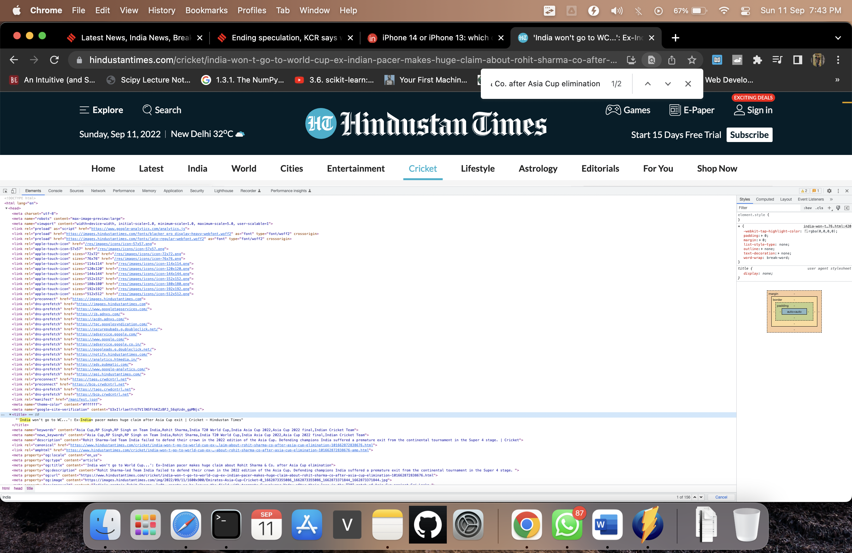

<head> <title>